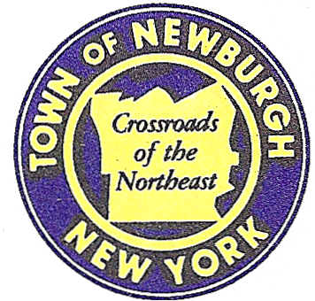

TOWN OF NEWBURGH
_______Crossroads of the Northeast __________________________
OLD TOWN HALL
308 GARDNERTOWN ROAD NEWBURGH, NEW YORK 12550

PLANNING BOARD
JOHN P. EWASUTYN, CHAIRMAN
TELEPHONE 845-564-7804
FAX 845-564-7802
E-MAIL: planningboard@townofnewburgh.org

PLANNING BOARD AGENDA

December 7th, 2017

*PLEASE NOTE: The Planning Board Meeting will start at 7:00 P.M. and all Applicants/Representatives
are to be present at that time. The Meeting will be held in the Meeting Room of Town Hall,
located at 1496 Route 300, Newburgh NY.*

- O’Herron Timber Harvest (17-29) INITIAL APPEARANCE
O’Herron Rd. & Ridgefield Lane TIMBER HARVEST
Section 17, Block 2, Lot 120.2 & 133
Zone:
Rep: Christopher Prentis C.F.
Lower Hudson Forestry Services, LLC
Nyack, NY 10960

2. Rhinebeck Realty-Aspen Dental (15-03) AMENDED SITE PLAN
1409 Route 300
Section 60, Block 3, Lot 40.2
Zone: IB
Rep: Brian O’Connor/Frohling Sign Co.
711 Executive Blvd. Suite G.
Valley Cottage, NY 10989

*WORK SESSION*
Project Readiness Discussion scheduled for 6:00 p.m. in the Meeting Room of
Town Hall on Thursday, December 7th, 2017.*

PLANNING BOARD BUSINESS
WORK SESSION

- McNally/Siegel Lot Line Change (12-17) Requesting a six month extension from
December 7, 2017 to June 7, 2017.

- Lands of Zazon (4-29) Requesting a six month extension from December 7, 2017 to
June 7, 2017.

*WORK SESSION*
Project Readiness Discussion scheduled for 6:00 p.m. in the Meeting Room of
Town Hall on Thursday, December 7th, 2017.*

